|  |
| --- |
| Hochschule Rhein-Waal  Rhine-Waal University of Applied Sciences  Faculty of Communication and Environment  Prof. Dr. Irmgard Buder  Prof. Dr.-Ing. Joachim Gebel |
| Experimental Study on the Production of Milk Powder using a Belt Dryer  Requirements of the Degree of  Bachelor of Science  in  Environment and Energy  by  Name  Street  City  Matriculation Number:  000000  Submission Date:  19.01.2014 |

# Abstract

The production of skim milk powder is a promising market due to several nutritional and logistical benefits associated with the dry milk product. However, recent drying technologies such as spray and drum dryers still suffer from drawbacks concerning economic and environmental feasibility. Thus a competitive technology has been developed by Fraunhofer UMSICHT research institute in form of a belt dryer prototype which is ought to dry at moderate temperature regimes producing high quality milk powder at low costs and low environmental impact. Nevertheless, as the dryer is still at premature stage, its drying process needed to be assessed by using DOE to analyse the effects of the three independent variables milk layer thickness, belt velocity and water bath temperature on the dry matter of the resulting milk powder. Based on the outcomes of two independent experimental series, the dryer’s stable operational drying process has been defined and verified using the thermodynamic principles of transient heat conduction. Additionally, the competitiveness of the device has been examined and optimization ideas were collected. It can be concluded that even if it may be possible to produce high quality powder at low costs the dryer in its recent state is not competitive in terms of production rates. Furthermore, it has multiple flaws which first need to be eliminated and optimized before using the dryer in future stable operation.

Keywords: Skim milk powder, belt dryer, DOE, linear regression analysis, transient heat conduction.

# Confidentiality Clause

The following Bachelor thesis contains confidential data and information disclosed by Fraunhofer UMSICHT research institute. It may not be disclosed, published or made known in any other manner, including in the form of extracts without the permission of Fraunhofer UMSICHT research institute. The Bachelor thesis is made available to the members of the Examination Board solely for the purpose of assessment.

Table of Contents

List of Abbreviations vi

List of Symbols viii

List of Figures ix

List of Tables xi

1 Introduction 1

2 Thermodynamic Principles 3

2.1 Introduction into Transient Heat Conduction 3

2.2 Lumped System Approach 5

2.3 Convective Heat Transfer Coefficient 6

3 Dairy Industry and Chemistry 8

3.1 Dairy Market 8

3.2 Dairy Products 9

3.3 Milk Powder Production 11

3.4 Nutritional Value of Milk Powder 16

3.5 Fundamentals of Dairy Chemistry 19

3.5.1 Protein Denaturation 19

3.5.2 Maillard Effect 20

4 Methodology 21

4.1 Statistical Methodology 21

4.1.1 Introduction into Design of Experiments (DOE) 21

4.1.2 Step by Step Approach on Designing an Experiment 22

4.2 Chemical Methodology – Moisture Content and Dry Matter 24

4.2.1 Determination of total solids content of milk, cream and evaporated milk according to ISO 6731:2010 26

4.2.2 Determination of moisture content of dried milk products using halogen drying 27

5 Design of Experiments 29

6 Experimental Part 41

6.1 Experimental Series 1 – OFAT Analysis 41

6.1.1 Materials & Methods 41

6.1.2 Observations & Results 43

6.1.3 Discussion 44

6.2 Experimental Series 2 – Full Factorial Analysis 47

6.2.1 Materials & Methods 47

6.2.2 Observations & Results 48

6.2.3 Discussion 49

7 Application and Verification of Results 53

7.1 Development of an Excel Tool 53

7.2 Verification of Results 55

7.3 Economic Feasibility of Belt Drying in Comparison to Spray Drying and Drum Drying ……………………………………………………………………………………….60

7.4 Optimization Ideas 61

8 Conclusion and Outlook 64

List of References 66

Annex 69

Appendix A. Data Tables 69

Declaration of Authenticity 71

# List of Abbreviations

$°C$ Unit; Degree Celsius

$CD$ Compact disc

$cm$ Unit; Centimetre

$DOE$ Design of experiments

$DVA$ Deutsche Vacuumapparate

$e. g.$ Latin: Exempli gratia; For example

$etc.$ Latin: Et cetera

$EU$ European Union

$e. V.$ Eingetragener Verein

$Fig.$ Figure

$g$ Unit; gram

$HMF$ 5-Hydroxymethylfurfural

$i. e.$ Latin: It est; That is

$J$ Unit; Joule

$K$ Unit; Kelvin

$kg$ Unit; Kilogram

$kPa$ Unit; Kilopascal

$m$ Unit; Metre

$MF$ Microfiltration

$MilchErzV$ Milcherzeugnisverordnung

$min$ Unit; Minute

$MIV$ Milchindustrie-Verband

$ml$ Unit; Millilitre

$mm$ Unit; Millimetre

$MPa$ Unit; Megapascal

$NF$ Nanofiltration

$OFAT$ One-factor-at-a-time analysis

$PET$ Polyethylene terephthalate

$RO$ Reverse osmosis

$rpm$ Unit; Rotations per minute

$s$ Unit; Second

$TS$ Total solids

$UF$ Ultrafiltration

$USDEC$ US Dairy Export Council

$VDI$ Verein Deutscher Ingenieure

$W$ Unit; Watt

# List of Symbols

$\%$ Percentage

$α$ Greek letter alpha; Name or diffusivity

$A$ Surface area

$β$ Greek letter beta

$Bi$ Biot number

$c_{p}$ Specific heat capacity

$δ$ Greek letter delta; Difference operator

$∆$ Greek letter capital delta; Difference operator

$d$ Difference operator or thickness

$η$ Greek letter eta; Dynamic viscosity

$h$ Convectional heat transfer coefficient

$κ$ Greek letter kappa

$k$ Thermal conductivity; Statistics: Number of influencing factors

$L$ Statistics: Number of levels

$L_{c}$ Characteristic length

$m$ Mass

$\dot{M}$ Mass flow

$N$ Statistics: Sample size

$Nu$ Nusselt number

$P$ Prandtl number

$\dot{Q}$ Thermal current

$ρ$ Greek letter rho; Density

$R$ Reynolds number

$T$ Temperature

$t$ Time

$v$ Flow velocity

$V$ Volume

$\dot{W}$ Internal source of thermal energy

# List of Figures

Figure 1. Annual production of dry milk products in Germany since 2005. Own illustration based on the publication of the German MIV developed using Microsoft Excel (Milchindustrie-Verband e.V. 2014). 9

Figure 2. Simple block flow diagram of standard milk powder production. Own illustration developed using Microsoft PowerPoint. 11

Figure 3. Schematic presentation of how membrane separation works. Own illustration based on a publication by T. Melin and R. Rautenbach developed using Microsoft PowerPoint (Melin & Rautenbach 2007). 14

Figure 4. Schematic presentation of typical membrane separation technologies used for the production of milk concentrate classified depending on their particle selectivity (Hartlieb 2014). 14

Figure 5. A schematic example of an irreversible protein denaturation. Left: native molecule in its original conformation. Right: irreversibly denatured molecule stabilized by covalent bonds. Own illustration developed using Microsoft PowerPoint. 19

Figure 6. A technical process with influencing factors and dependent output variables simplified as black box approach. Own illustration developed using Microsoft PowerPoint. 21

Figure 7. Stepwise approach on how to design an experimental series using DOE. Own illustration based on a publication by V. P. Astakhov developed using Microsoft PowerPoint (Astakhov 2012). 23

Figure 8. Three types of water relevant in the food industry with increasing binding strength. Own illustration based on the application brochure of Mettler Toledo developed using Microsoft Visio (METTLER TOLEDO 2002). 25

Figure 9. Block flow diagram of the production of milk powder using a belt dryer. Own illustration developed using Microsoft Visio. 30

Figure 10. Process flow diagram of belt dryer. Own illustration developed using Microsoft Visio. 31

Figure 11. Front supply part of the belt dryer and the doctor knife. 32

Figure 12. Bolt system to adjust the doctor knife. 33

Figure 13. Control monitor to run the belt dryer. 35

Figure 14. Motor attached to clamping roll moving the belt forward. 35

Figure 15. Scatter diagram displaying the relationship between the belt velocity in percentage on the x-axis and the residence time in seconds and minutes on the y-axes. 36

Figure 16. Heater, pump, ventilation system and computer control station. 37

Figure 17. Depiction of measuring spots to detect waterbath temperature. Own illustration developed using Microsoft PowerPoint. 38

Figure 18. Scatter diagram comparing the heating process over time of the four measuring spots and the heating vessel. 38

Figure 19. Scatter diagram representing the heating process of the indoor air in comparison to the heating vessel. 39

Figure 20. Scatter diagram displaying the relationship between layer thickness on the x-axis and dry matter on the y-axis. 44

Figure 21. Scatter diagram displaying the relationship between belt velocity on the x-axis and dry matter on the y-axis. 46

Figure 22. Scatter diagram displaying the relationship between temperature on the x-axis and dry matter on the y-axis. 47

Figure 23. Measurements-Prognosis diagram aligning the observed measurements with the calculated prognosis values obtained using the regression function. Own illustration developed using Statistica. 50

Figure 24. 3D plot displaying the relationship between layer thickness, belt velocity and dry matter. Own illustration developed using Statistica. 51

Figure 25. 3D plot displaying the relationship between layer thickness, temperature and dry matter. Own illustration developed using Statistica. 52

Figure 26. 3D plot displaying the relationship between belt velocity, temperature and dry matter. Own illustration developed using Statistica. 52

Figure 27. Snapshot of a prototype Excel tool to determine adequate combinations of variables to exceed the target dry matter of 96 %. Own illustration developed using Microsoft Excel. 54

Figure 28. Flow rate diagram with calculations. Own illustration developed using Microsoft PowerPoint. 61

# List of Tables

Table 1. Thermal conductivities of different metals, non-metal solids and fluids at a temperature of 20 °C and a pressure of 100 kPa. Own list based on the book “Wärme- und Stoffübertragung” by K. Stephan and H. D. Baehr (Baehr & Stephan 2013). 3

Table 2. Dry milk products according to the MilchErzV (Bundesministeriums der Justiz und für Verbraucherschutz 1970). 11

Table 3. Typical composition of skim and whole milk powders in weight percentage. Own list based on a publication by the U.S. Dairy Export Council (USDEC 2005). 17

Table 4. Different measuring methods to determine the total solids content of a sample. Own list based on an illustration by Mettler Toledo (METTLER TOLEDO 2002). 25

Table 5. Visualization of scoop size calculation based on sampling area's size and layer thickness. 42

Table 6. Dry matter data obtained during the OFAT analysis. 43

Table 7. DOE set up using STATISTICA. 48

Table 8. Results of the full factorial analysis with the average dry matter values underlined in bold numbers. 49

Table 9. Results of the regression analysis. Own list based on the outputs of Statistica. 49

Table A. 1. Transformation of belt velocity in percentage into residence time in minutes and seconds. 69

Table A. 2. Temperature measurements (T1-T4) at four different spots in the waterbath in comparison to the temperature displayed at the heater (TH). 69

Table A. 3. Indoor air temperature (TI) measurements in comparison to the temperature displayed at the heating vessel (TH). 70

# 1 Introduction

Global milk powder production and especially skim milk powder production experienced a continuous growth in demand over the last years especially in the major manufacturing countries such as the United States and Germany. Not only do costumers and industry appreciate its high nutritional value and health benefits associated with its consumption but the powder is also interesting as valuable ingredient in various food production sectors as it has a prolonged shelf life, reduced logistical costs and is economically feasible in production. Due to this pronounced increase in demand, milk powder production is a promising market in the food industry.

Recent and most frequently used technologies in milk powder production are the spray and drum drying technology although those two technologies are associated with many disadvantages such as high capital and running costs, reduced powder quality and low thermal efficiency. Therefore, Fraunhofer UMSICHT research institute in Oberhausen developed a new belt dryer prototype as competitive device for future powder production. Nevertheless, the inadequate drying process is not the only process chain within the dairy industry that needs to be improved to become economically and environmentally feasible. Thus, Fraunhofer UMSICHT in collaboration with several other institutions across Europe founded an EU project called “SUSMILK”. This project aims at developing a green, sustainable dairy concept. By re-designing process chains within the dairies their goal is to reduce water and energetic losses to a minimum. The production of an advanced drying process in form of a belt dryer hereby is a key task of the project.

The advanced dryer is ought to use thermal waste energy from the dairy and operate at low temperatures, thus saving energetic costs while still performing at high thermal efficiencies without impairing the quality of the final product. However, as this prototype is still in development, there is no experimental data available on its drying process and stable operation. Therefore, this bachelor thesis aims at answering three major research questions:

1. Is it possible to produce milk powder using the belt dryer?
2. What are optimum drying conditions for future stable operation?
3. Is the technology economically feasible and competitive with other technologies and how can it be further improved to become competitive in the future?

This thesis is split in several chapters to guide the reader through the theoretical and practical parts of the bachelor project. After a short introduction into thermodynamic principles which are relevant to understand the basic drying process of the belt dryer, the dairy industry and especially the milk powder industry are introduced with regard to market situation, basic definitions, the general milk powder production chain, nutritional benefits of milk powder and basic chemical reactions which might occur during production and handling of the powder. Afterwards, the methodology applied during the experimental part are discussed mainly focussing on design of experiments as statistical method and the determination of dry matter of milk concentrates and milk powders as chemical methods. Prior to starting the experimental part, the belt dryer and the variables relevant to optimize the drying process are defined and analysed to adequately design the subsequent experimental series. The main independent factors examined are the amount of milk applied to the belt in terms of layer thickness, the production rate in terms of belt velocity and the water bath temperature. On the other hand, the main dependent variable is the quality of the final powder with regard to dry matter. Then, the thesis focuses on the outcomes of two independent experimental series, one focusing on the single effect of the three independent factors on the dependent variable and the other focusing on the intercorrelated effect of all independent variables on it. For each experimental series, the materials and methods applied, as well as the observations made during the experiments, the results obtained from the experiments and the discussion of those results are displayed. In the next chapter, the results of the two experimental series are applied to set up a user friendly Excel tool for future handling and operation of the dryer. Furthermore, the results are verified using the thermodynamic principles introduced in the theoretical part and lastly optimization ideas and the economic feasibility of the dryer in comparison to conventional drying systems are analysed.

# 2 Thermodynamic Principles

Heat transfer is the transfer of energy caused by a temperature gradient between a diabatic system and its ambience (Stephan et al. 2013). According to the second law of thermodynamics heat hereby always flows in the direction of decreasing temperature. There are three types of heat transfer: Heat conduction, convective heat transfer and thermal radiation. For the purpose of this bachelor thesis heat conduction is of primary interest. Therefore, heat conduction is explained in more detail in the subsequent chapters. Information on convective heat transfer and thermal radiation can be found in the recommended literature.

## 2.1 Introduction into Transient Heat Conduction

Heat conduction occurs in solid and static liquid and gaseous bodies. It can either be stationary (constant over time) or transient (changing over time). To understand transient heat conduction problems it is fundamental to also understand the basics of stationary heat conduction. Therefore, heat conduction through a plane wall is explained first. Heat conduction is caused by the interaction of more energetic atoms and molecules with less energetic ones thus passing energy from one atom or molecule to the next. Heat conduction is therefore also called molecular heat transfer and is usually visible as a vibration spreading across the molecules. The rate of change in temperature over a distinct length $\frac{dT}{dx}$ is called temperature gradient. The amount of heat conducted is called thermal current $\dot{Q}$. Equation 2-1 is called Fourier’s equation of heat conduction and displays the thermal current $\dot{Q}$ as a function of the surface area A of a distinct object and the temperature gradient (Stephan et al. 2013; Tipler & Mosca 2008):

|  |  |  |
| --- | --- | --- |
|  |  | (2-1) |

The proportionality factor k is called thermal conductivity and is measured in W/(m*K). Thermal conductivity is dependent on the material through which heat is conducted. Materials with a high thermal conductivity such as metals are good thermal conductors whereas materials with a low thermal conductivity such as gases and porous materials are good thermal resistors and thus serve as insulators (Tipler & Mosca 2008). Table 1 exemplarily lists thermal conductivities of various materials at 20 °C and 100 kPa.

Table 1. Thermal conductivities of different metals, non-metal solids and fluids at a temperature of 20 °C and a pressure of 100 kPa. Own list based on the book “Wärme- und Stoffübertragung” by K. Stephan and H. D. Baehr (Baehr & Stephan 2013).

|  |  |
| --- | --- |
| Material at 20 °C and 100 kPa | Thermal Conductivity k [W/(m*K)] |
| *Metals/Alloys* |  |
| Silver | 427 |
| Copper | 399 |
| Aluminum | 237 |
| Iron | 81 |
| *Non Metal Solids* |  |
| Ice (0°C) | 2.25 |
| Concrete | 1 |
| Window Glass | 0.76 |
| Paper | 0.12 |
| *Fluids* |  |
| Water | 0.5985 |
| O2 | 0.0260 |
| Air | 0.02587 |
| CO2 | 0.01622 |

Fourier’s equation is only valid for one directional heat transfer. However, if heat is distributed in three dimensions throughout a body the general heat equation needs to be used to calculate the change in temperature over time $\frac{∂T}{∂t}$ in dependence of the heat transfer across all three Cartesian coordinates x, y and z. The heat equation is denoted in Equation 2-2 (Baehr & Stephan 2013; Çengel & Ghajar 2015):

|  |  |  |
| --- | --- | --- |
|  | $$\frac{∂}{∂x}\left(α\frac{∂T}{∂x}\right)+\frac{∂}{∂y}\left(α\frac{∂T}{∂y}\right)+\frac{∂}{∂z}\left(α\frac{∂T}{∂z}\right)+\frac{\dot{W}}{c_{p}ρ}=\frac{∂T}{∂t}$$ | (2-2) |

The constant α hereby is the material dependent thermal diffusivity[1], cp is the specific heat capacity, ρ is the material’s density and $\dot{W}$ is the thermal energy created at the inside of the material due to e.g. an electrical resistance, a chemical or nuclear reaction. There are three approaches to solve Equation 2-2. Firstly, it is possible to conduct an experimental series to empirically compute the heat transfer. Secondly, the formula can be discretized and solved by using a computer program or lastly, an analytical approach is used. Experimental as well as discretizational approaches are very time consuming. Therefore, only the analytical way is feasible. Nevertheless, this original equation is too complex to be solved analytically, thus it is further simplified by making several assumptions. Usually, it is assumed that all constants are temperature independent, that there is no internal source of thermal energy $\dot{W}$ and that the heat transfer is one-dimensional only.

So, the equation can be simplified to Equation 2-3 (Baehr & Stephan 2013; Meyer 2014a; Çengel & Ghajar 2015):

|  |  |  |
| --- | --- | --- |
|  | $$\frac{∂T}{∂t}=α\frac{∂²T}{∂x²}$$ | (2-3) |

There are now two possibilities:



$\frac{∂T}{∂t}=0$

$\frac{∂T}{∂t}≠0$

If the change in temperature over time equals zero as in the first case the heat transfer does not change over time and thus it is a state of stationary heat conduction. However, if the change in temperature over time does not equal zero as displayed in the second case the heat transfer indeed changes over time and is thus called transient heat conduction. One way of solving a transient heat transfer problem is to use the lumped system approach (Çengel & Ghajar 2015).

## 2.2 Lumped System Approach

The lumped system approach assumes that if a body is subjected to a temperature different from its own temperature, all points of the body have the same change in temperature over time independent from their position relative to the ambience. This behavior is only possible if the conductive resistance of the body is very small so that heat can be easily and evenly conducted to each point inside the body. Equation 2-4 visualizes conductive thermal resistances as a function of the body’s thickness Δx, its thermal conductivity k and its surface area A. So, when looking at the equation it becomes obvious that the lumped system approach works best for small objects having a large thermal conductivity, such as a small steel bead or a thin copper foil (Meyer 2014b; Çengel & Ghajar 2015).

|  |  |  |
| --- | --- | --- |
|  |  | (2-4) |

The lumped system approach is based on the assumption that the convective heat transfer rate $\dot{Q}$ into or out of an arbitrary body is the same as the increase or decrease in energy inside this body over time. So, Equation 2-5 can be set up with h being the convective heat transfer coefficient, T∞ being the ambient temperature, T(t) being the object’s internal temperature at any point in time, m being the object’s mass and V being its volume (Meyer 2014c; Çengel & Ghajar 2015):

|  |  |  |
| --- | --- | --- |
|  | $$h*A*\left(T_{∞}-T\left(t\right)\right)dt=\frac{m*c_{p}*dT}{dt}=\frac{ρ*V*c_{p}*d(T-T_{∞})}{dt}$$ | (2-5) |

After a series of rearrangements and a final integration, Equation 2-6 can be set up with Ti being the initial temperature of the object of interest. This equation can now be used to calculate the temperature T(t) at any point in time (Meyer 2014c; Çengel & Ghajar 2015).

|  |  |  |
| --- | --- | --- |
|  | $$\frac{T\left(t\right)-T_{∞}}{T_{i}-T_{∞}}=e^{-\left(\frac{h*A}{ρ*V*c_{p}}\right)t}=e^{-bt}$$ | (2-6) |

However, the lumped system approach is only applicable to describe a practical problem if the Biot number of the object of interest is smaller or equal to a value of 0.1. The Biot number can be calculated using Equation 2-7 with Lc being the object’s ratio of its volume to its surface area, called characteristic length. In most planar problems it is sufficient to take half an object’s thickness as an estimation for the characteristic length (Meyer 2014c; Çengel & Ghajar 2015).

|  |  |  |
| --- | --- | --- |
|  | $$Bi=\frac{h*L_{c}}{k}=\frac{h*V}{k*A}$$ | (2-7) |

When analyzing Equation 2-7 it becomes obvious that the Biot number basically describes the ratio of the conductive resistance to the convective resistance. So, for each scenario where the convective resistance is at least ten times higher than that of the conduction, the lumped system approach yields accurate results. Nevertheless, the Biot number is only a measure of the accuracy, so even if the Biot number is slightly higher than 0.1 the findings of the lumped system approach can still be used however their accuracy is lower than if the Biot number would have been smaller than 0.1. So, all in all, the lumped system approach is applicable if the Biot number, the characteristic length and the convective heat transfer coefficient are small and if the thermal conductivity of the object of interest is high (Çengel & Ghajar 2015).

## 2.3 Convective Heat Transfer Coefficient

One critical variable in the lumped system approach is the convective heat transfer coefficient h. The coefficient describes the convective heat flow through a fluid and is measured in W/m²K. It is dependent on the fluid’s medium, its flow and temperature dependent properties. In general, the coefficient increases with increasing flow velocity and turbulence of the liquid. Therefore, liquids which experience a forced convection induced by e.g. a pump usually have higher convective heat transfer coefficients than liquids which experience natural, free convection due to temperature differences only. Estimated values for different gases and liquids in different situations can be found in tables. Nevertheless, in some situations the exact value can only be calculated. One way to calculate the convective heat transfer coefficient h is displayed in Equation 2-8 (Windisch 2014):

|  |  |  |
| --- | --- | --- |
|  | $$h=\frac{k}{L_{c}}*Nusselt Number$$ | (2-8) |

According to this equation, h depends on the thermal conductivity of a medium, its characteristic length and a constant called Nusselt number. Nusselt number is a function of two other constants namely of Reynolds and Prandtl number. The exact relationship between the three numbers varies depending on various factors, such as the structure’s form through which the fluid is moving (e.g. through a pipe, along a planar wall etc.), how the fluid’s flow is directed towards the surface to be heated and the roughness of the surface structure of the object to be heated. In general, when a fluid moves along a flat plane the Nusselt number can be estimated using Equation 2-9 (Baehr & Stephan 2013):

|  |  |  |
| --- | --- | --- |
|  | $$Nu=0.331*R^{\frac{1}{2}}*P^{\frac{1}{3}}$$ | (2-9) |

Reynolds and Prandtl number themselves can be calculated using Equations 2-10 and 2-11 with Reynolds describing the flow type and Prandtl focusing on the relevant variables of convective heat transfer (Windisch 2014):

|  |  |  |
| --- | --- | --- |
|  | $$R=\frac{v*L_{c}*ρ}{η}$$ | (2-10) |
|  | $$P=\frac{η*c_{p}}{k}$$ | (2-11) |

The constant η hereby indicates the dynamic viscosity of the fluid and v being the fluid’s average flow velocity.

# 3 Dairy Industry and Chemistry

## 3.1 Dairy Market

Figure 1 displays the development of the annual production of dry milk products in Germany since 2005 based on the recent publication by the MIV (Milchindustrie-Verband e.V. 2014; Spreer 2011).

Figure 1. Annual production of dry milk products in Germany since 2005. Own illustration based on the publication of the German MIV developed using Microsoft Excel (Milchindustrie-Verband e.V. 2014).

## 3.2 Dairy Products

Table 2 summarizes the most relevant powders according to the German “Milcherzeugnisverordnung”.

Table 2. Dry milk products according to the MilchErzV (Bundesministeriums der Justiz und für Verbraucherschutz 1970).

|  |  |
| --- | --- |
| Dry milk product | Milk fat |
| Whole fat dry milk products   * High fat cream powder * High fat cream yoghurt powder * High fat cream kefir powder | ≥ 42 % |
| Regular dry milk products   * Whole milk powder * Yoghurt powder * Kefir powder | ≥ 26 |
| Semi-skimmed dry milk products   * Semi-skimmed milk powder * Semi-skimmed yoghurt powder * Semi-skimmed kefir powder | 1.5 – 26 % |
| Skimmed dry milk products   * Skim milk powder * Skim milk yoghurt powder * Skim milk kefir powder | ≤ 1.5 % |
| Dry buttermilk | ≤ 15 % |

## 3.3 Milk Powder Production

Figure 2 displays a basic block flow diagram of how milk powder can be produced.

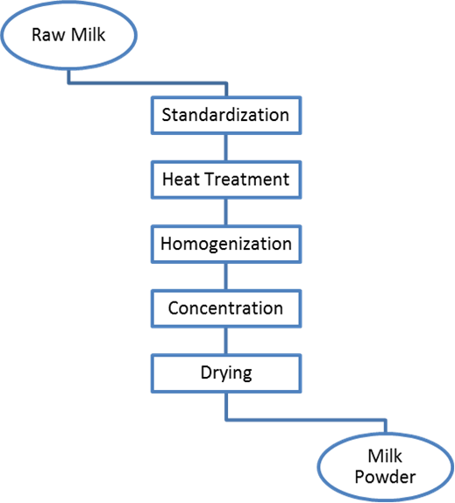

Figure 2. Simple block flow diagram of standard milk powder production. Own illustration developed using Microsoft PowerPoint.

*Standardization*

*Heat Treatment*

*Homogenization*

*Concentration*

Figure 3 displays a simplified membrane module and how it separates the permeate and concentrate from the feed (Melin & Rautenbach 2007).

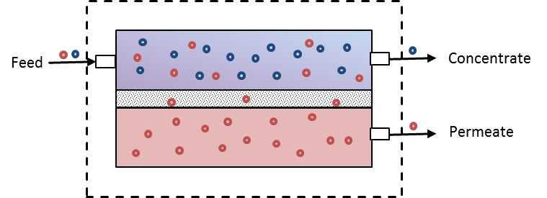

Figure 3. Schematic presentation of how membrane separation works. Own illustration based on a publication by T. Melin and R. Rautenbach developed using Microsoft PowerPoint (Melin & Rautenbach 2007).

Figure 4 displays a schematic presentation of different membrane separation technologies used in the milk industry depending on their particle selectivity (Hartlieb 2014).

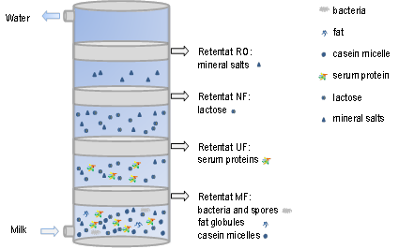

Figure 4. Schematic presentation of typical membrane separation technologies used for the production of milk concentrate classified depending on their particle selectivity (Hartlieb 2014).

*Drying*

## 3.4 Nutritional Value of Milk Powder

Table 3 visualizes the major components of skim and whole milk powders based on their weight percentage.

Table 3. Typical composition of skim and whole milk powders in weight percentage. Own list based on a publication by the U.S. Dairy Export Council (USDEC 2005).

|  |  |  |
| --- | --- | --- |
| Nutrient | Skim Milk Powder | Whole Milk Powder |
| Protein | 34-37 % | 24.5-27 % |
| Lactose | 49.5-52 % | 36-38.5 % |
| Lipids | 0.6-1.25 % | 26-40 % |
| Ash Content | 8.2-8.6 % | 5.5-6.5 % |
| Moisture | 3-4 % | 2-4.5 % |

*Dairy Proteins*

*Carbohydrates*

*Lipids*

*Vitamins*

*Minerals*

## 3.5 Fundamentals of Dairy Chemistry

### 3.5.1 Protein Denaturation

Figure 5 displays a schematic drawing of an irreversible protein denaturation caused by the formation of covalent bonds between the peptide chains of a protein.



Figure 5. A schematic example of an irreversible protein denaturation. Left: native molecule in its original conformation. Right: irreversibly denatured molecule stabilized by covalent bonds. Own illustration developed using Microsoft PowerPoint.

### 3.5.2 Maillard Effect

bntrnnz

# 4 Methodology

## 4.1 Statistical Methodology

### 4.1.1 Introduction into Design of Experiments (DOE)

Figure 6 displays a simplified representation of this definition.

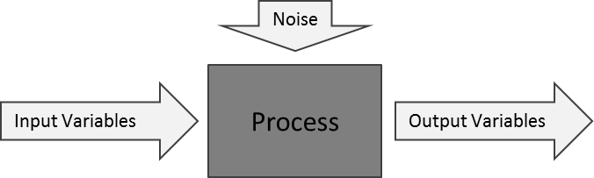

Figure 6. A technical process with influencing factors and dependent output variables simplified as black box approach. Own illustration developed using Microsoft PowerPoint.

So the sample size can be calculated using Equation 4-1:

|  |  |  |
| --- | --- | --- |
|  | $$N=L^{k}$$ | (4-1) |

### 4.1.2 Step by Step Approach on Designing an Experiment

To successfully design an experiment several steps have to be followed which are displayed in Figure 7:

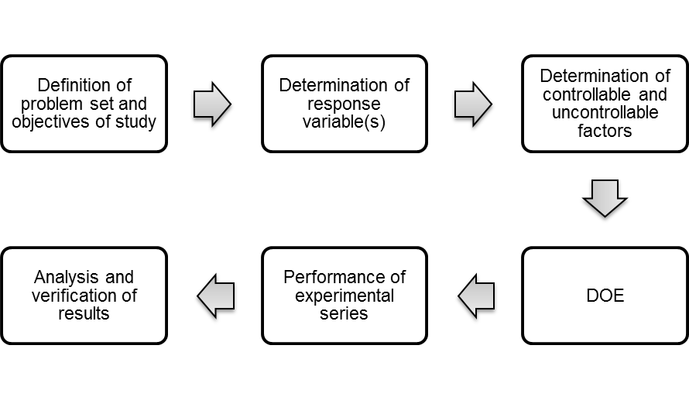

Figure 7. Stepwise approach on how to design an experimental series using DOE. Own illustration based on a publication by V. P. Astakhov developed using Microsoft PowerPoint (Astakhov 2012).

## 4.2 Chemical Methodology – Moisture Content and Dry Matter

Figure 8 depicts a visualization of surface water, pore water and adhesive water (METTLER TOLEDO 2002).



Figure 8. Three types of water relevant in the food industry with increasing binding strength. Own illustration based on the application brochure of Mettler Toledo developed using Microsoft Visio (METTLER TOLEDO 2002).

Table 4 displays the most relevant methods (METTLER TOLEDO 2002):

Table 4. Different measuring methods to determine the total solids content of a sample. Own list based on an illustration by Mettler Toledo (METTLER TOLEDO 2002).

|  |  |  |  |
| --- | --- | --- | --- |
| *Thermogravimetric Methods* | *Chemical Methods* | *Spectroscopic Methods* | *Miscellaneous* |
| * Infrared Drying * Halogen Drying * Drying Oven Method * Microwave Drying * Phosphorus Pentoxide Method * Distillation | * Karl-Fischer Titration * Calcium Carbonide Method | * Infrared Spectroscopy * Microwave Spectroscopy * Nuclear Magnetic Resonance (NMR) Spectroscopy | * Density Determination * Refractometry * Conductometry * Gas Chromato-graphy |

## 4.2.1 Determination of total solids content of milk, cream and evaporated milk according to ISO 6731:2010

Therefore, the amount of dry matter of the milk concentrate can be calculated using Equation 4-2 (ISO International Organization for Standardization 2010):

|  |  |  |
| --- | --- | --- |
|  | $$DM\left(\%\right)=\frac{final dry weight}{initial weight}*100=\frac{m_{f}}{m_{i}}*100$$ | (4-2) |

## 4.2.2 Determination of moisture content of dried milk products using halogen drying

# 5 Design of Experiments

Prior to starting the experiments an experimental design according to Chapter 4.1.2 needs to be set up.

*Problem Definition*

*Determination of Response and Independent Variables*

*Definition of the Belt Dryer in Terms of Independent Variables*

# 6 Experimental Part

## 6.1 Experimental Series 1 – OFAT Analysis

### 6.1.1 Materials & Methods

### 6.1.2 Observations & Results

### 6.1.3 Discussion

## 6.2 Experimental Series 2 – Full Factorial Analysis

### 6.2.1 Materials & Methods

### 6.2.2 Observations & Results

### 6.2.3 Discussion

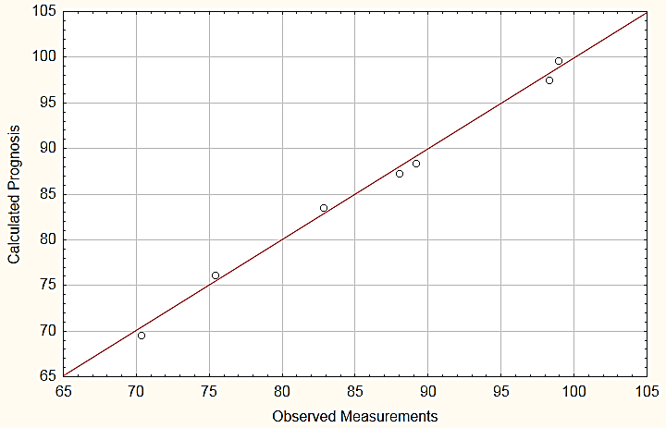

Figure 23. Measurements-Prognosis diagram aligning the observed measurements with the calculated prognosis values obtained using the regression function. Own illustration developed using Statistica.

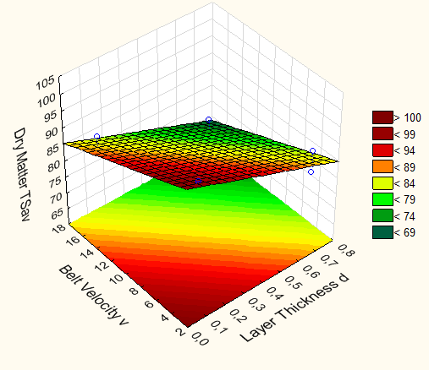

Figure 24. 3D plot displaying the relationship between layer thickness, belt velocity and dry matter. Own illustration developed using Statistica.

# 7 Application and Verification of Results

## 7.1 Development of an Excel Tool



Figure 27. Snapshot of a prototype Excel tool to determine adequate combinations of variables to exceed the target dry matter of 96 %. Own illustration developed using Microsoft Excel.

## 7.2 Verification of Results

## 7.3 Economic Feasibility of Belt Drying in Comparison to Spray Drying and Drum Drying

## 7.4 Optimization Ideas

# 8 Conclusion and Outlook

# List of References

Astakhov, V. P., 2012. Design of Experiment Methods in Manufacturing: Basics and Practical Applications. *In:* J. P. Davim, ed. *Statistical and Computational Techniques in Manufacturing*. Berlin, Heidelberg: Springer Berlin Heidelberg, pp. 1–54

Baehr, H. D., and Stephan, K., 2013. *Wärme- und Stoffübertragung.* Berlin, Heidelberg: Springer Berlin Heidelberg

Barbosa-Cánovas, G. V. et al., 2005. *Food powders. Physical properties, processing, and functionality.* New York: Kluwer Academic/Plenum Publishers. (Food Engineering Series)

Barbosa-Cánovas, G. V., and Vega-Mercado, H., 1996. *Dehydration of foods.* New York: Chapman & Hall. (Food Engineering Series)

Belitz, H.-D., Grosch, W., and Schieberle, P., 2008a. Aminosäuren, Peptide und Proteine. *In:* H.-D. Belitz, W. Grosch and P. Schieberle, eds. *Lebensmittelchemie*. Berlin, Heidelberg: Springer Berlin Heidelberg (Springer-Lehrbuch), pp. 9–95

Belitz, H.-D., Grosch, W., and Schieberle, P., 2008b. Kohlenhydrate. *In:* H.-D. Belitz, W. Grosch and P. Schieberle, eds. *Lebensmittelchemie*. Berlin, Heidelberg: Springer Berlin Heidelberg (Springer-Lehrbuch), pp. 252–345

Belitz, H.-D., Grosch, W., and Schieberle, P., 2008c. Milch und Milchprodukte. *In:* H.-D. Belitz, W. Grosch and P. Schieberle, eds. *Lebensmittelchemie*. Berlin, Heidelberg: Springer Berlin Heidelberg (Springer-Lehrbuch), pp. 514–563

Bundesministerium für Gesundheit, 2000. Milchverordnung. MilchV

Bundesministeriums der Justiz und für Verbraucherschutz, 1970. Milcherzegnisverordnung. MilchErzV

Cavazzuti, M., 2013. Design of Experiments. *In:* M. Cavazzuti, ed. *Optimization Methods*. Berlin, Heidelberg: Springer Berlin Heidelberg, pp. 13–42

Çengel, Y. A., and Ghajar, A. J., 2015. *Heat and mass transfer. Fundamentals & applications*. Fifth edition. New York, N. Y: McGraw-Hill

Diehl, J. F., 2000. *Chemie in Lebensmitteln. Rückstände, Verunreinigungen, Inhalts- und Zusatzstoffe*. 1st ed. Weinheim, New York: Wiley-VCH

DVA Holland-Merten GmbH, 2014. *Effektive Trocknungsprozesse unter Vakuum. Vakuum-Walzentrockner als schonendes Trocknungsverfahren.* Südharz. 2014

GEA Niro, 2010. *Milk Powder Technology. Evaporation and Spray Drying*. 5th ed. Westergaard, V., ed. Copenhagen

Hartlieb, M., 2014. *Experimentelle Untersuchungen zur dynamischen Filtration am Beispiel von Mikro- und Ultrafiltration.* Oberhausen. 6 June

IDF, 2013. *Neues Faktenblatt des IDF. Die wirtschaftliche Bedeutung der Milchwirtschaft.* Verband der deutschen Milchwirtschaft e.V., ed. Berlin: International Dairy Federation.

ISO International Organization for Standardization ISO 5537:2004, 2004. *Dried milk - Determination of moisture content (Reference method).* Berlin: Beuth Verlag

ISO International Organization for Standardization ISO 6731:2010, 2010. *Milk, cream and evaporated milk - Determination of total solids content (Reference method).* Berlin: Beuth Verlag

Kapitza, M., 2009. *Design of Experiments.* Köln. 2009

Land, C. M. van't, 1991. *Industrial drying equipment. Selection and application.* New York: M. Dekker. (Chemical industries; v. 45)

Masters, K., 1991. *Spray drying handbook*. 5th ed. Burnt Mill, Harlow, Essex, England, New York: Longman Scientific & Technical; Wiley

Melin, T., and Rautenbach, R., 2007. *Membranverfahren. Grundlagen der Modul- und Anlagenauslegung*. 3rd ed. Berlin: Springer

METTLER TOLEDO, 2002. *Applikationsbroschüre: Methoden der Feuchtegehaltsbestimmung. Halogen Moisture Analyzer von METTLER TOLEDO.* METTLER TOLEDO, ed. Greifensee, Switzerland

Meyer, J., 2014a. *Lecture 01: Introduction to Transient Heat Conduction.* Pretoria, South Africa. 3 February

Meyer, J., 2014b. *Lecture 02: Transient Heat Transfer and Introduction to Lumped System Approach.* Pretoria, South Africa. 4 February

Meyer, J., 2014c. *Lecture 03: Unsteady Heat Transfer and Lumped System.* Pretoria, South Africa. 5 February

Milchindustrie-Verband e.V., 2014. *Herstellung von Kondensmilch-, Trockenmilch- und Molkenerzeugnissen in Deutschland. Zahlen - Daten - Fakten 2013.* Berlin

MORE, G. R., and Prasad, S., 1988. Thermal Conductivity of Concentrated Whole Milk. *Journal of Food Process Engineering*, 10(2), 105–112

O'Brien, J., 2009. Non-Enzymatic Degradation Pathways of Lactose and Their Significance in Dairy Products. *In:* P. McSweeney and P. F. Fox, eds. *Advanced Dairy Chemistry. Volume 3: Lactose, Water, Salts and Minor Constituents.* 3rd ed. New York, NY: Springer New York, pp. 231–294

Professional Plastics, 2014. *Thermal Properties of Plastic Materials.* Fullerton. Available at: <http://www.professionalplastics.com/professionalplastics/ThermalPropertiesofPlasticMaterials.pdf> [Accessed 11 December 2014]

Rambke, K., and Konrad, H., 1970a. Physikalische Eigenschaften flüssiger Milchprodukte. 1. Mitt. Dichte von Milch, Rahm und Milchkonzentraten. *Die Nahrung*, 14(2), 137–143

Rambke, K., and Konrad, H., 1970b. Physikalische Eigenschaften flüssiger Milchprodukte. 3. Mitt. Spezifische Wärmekapazität von Milch, Rahm und Milchkonzentraten. *Die Nahrung*, 14(6), 475–483

Ramirez, C. A., Patel, M., and Blok, K., 2009. From fluid milk to milk powder: Energy use and energy efffeciency in the European dairy industry. *Energy*, 31(12), 1984–2004

Spreer, E., 2011. *Technologie der Milchverarbeitung*. 10th ed. Hamburg: Behr

Stephan, P. et al., 2013. *Thermodynamik.* Berlin, Heidelberg: Springer Berlin Heidelberg. (Springer-Lehrbuch)

Tipler, P. A., and Mosca, G., 2008. *Physics for scientists and engineers*. 6th ed. New York, NY: W.H. Freeman

Töpel, A., 2004. *Chemie und Physik der Milch. Naturstoff - Rohstoff - Lebensmittel*. 1st ed. Hamburg: Behr

USDEC, 2005. *Reference Manual for U.S. Milk Powders. 2005 Revised Edition.* Lagrange, V., ed. Arlington, Virginia: U.S. Dairy Export Council.

VDI e.V., 2013. *VDI-Wärmeatlas*. 11th ed. Berlin: Springer Vieweg. (Springer reference)

Wang, S., 2013. *Lecture 02: Introduction to Heat Transfer.* Kamp-Lintfort. 24 October

Windisch, H., 2014. *Thermodynamik. Ein Lehrbuch für Ingenieure*. 5.,überarb. Aufl. München: Oldenbourg. (Oldenburg-Studium)

# Annex

## Appendix A. Data Tables

# Declaration of Authenticity

I, Isabell Eickhoff, hereby declare that the work presented herein is my own work completed without the use of any aids other than those listed. Any material from other sources or works done by others has been given due acknowledgement and listed in the reference section. Sentences or parts of sentences quoted literally are marked as quotations; identification of other references with regard to the statement and scope of the work is quoted. The work presented herein has not been published or submitted elsewhere for assessment in the same or a similar form. I will retain a copy of this assignment until after the Board of Examiners has published the results, which I will make available on request.

1. Thermal diffusivity is the ratio of the material’s conductivity to the sum of the material’s specific heat capacity and its density 🡪